AI-Powered FAQ
Assistant for Intelligent
Query Resolution

Team ID:SWTID-2026-9389
Team Size:4 Nos.
Team Leader | Yasmin T
Team Member | Yuvasri V
Team Member | Aishwarya B
Team Member | Priyadarshini M

1.Introduction
Artificial Intelligence (AI) has become an important technology in modern computer applications. It enables computer systems to perform tasks that normally require human intelligence, such as understanding language, identifying patterns, making decisions, and providing useful information. One of the practical applications of AI is the development of intelligent question-answering systems.
A Frequently Asked Questions (FAQ) system is designed to provide answers to commonly asked questions. Traditional FAQ systems usually contain a fixed list of questions and answers. Users have to search through the available information or find a question that closely matches their requirement. When the number of questions increases, finding the correct information manually can become time-consuming.
The project uses Natural Language Processing (NLP) concepts to process human language. Text preprocessing techniques can be used to clean and normalize the user's question before it is compared with the available FAQ data. A question-matching or similarity technique is then used to identify the most relevant FAQ entry.
The AI FAQ Assistant also provides a foundation for future improvements. Features such as multilingual support, voice-based interaction, semantic search, conversation history, and integration with advanced AI or Large Language Models can be added to make the system more capable.

2.Background of AI-FAQ Assistant
The rapid growth of Artificial Intelligence has changed the way people interact with computer systems. Earlier, users generally had to search through websites, documents, or FAQ pages to find the required information. With the development of AI and Natural Language Processing, computer systems can now process questions written in ordinary human language and provide relevant information.
An FAQ (Frequently Asked Questions) system is commonly used to answer questions that are repeatedly asked by users. For example, a college website may contain questions about admission, fees, working hours, courses, examinations, and contact information. A company may have FAQs related to products, services, orders, and customer support.
The background of this project is therefore based on three main concepts: Artificial Intelligence, Natural Language Processing, and Knowledge-Based Question Answering. These concepts work together to make information retrieval faster, simpler, and more user-friendly.
The system can be developed for a specific organization or domain by preparing a collection of frequently asked questions and their verified answers. As new questions arise, the knowledge base can be updated. This makes the system flexible and suitable for practical applications.

3. Problem Statement
In many organizations and institutions, users frequently ask the same questions regarding services, procedures, timings, applications, facilities, and other general information. Traditionally, users have to search through websites, documents, or FAQ pages to find the required information. When a large number of questions and answers are available, this manual searching process can be time-consuming and inconvenient.
Another limitation of traditional FAQ systems is that they often depend on exact keywords or predefined questions. Users may ask the same question using different words or sentence structures. In such cases, a conventional FAQ system may fail to identify the relevant answer even though the required information is already available.
Therefore, there is a need for an intelligent system that can accept questions in natural language, understand the user’s query, and identify the most relevant answer from a predefined knowledge base.
The main problem addressed by this project is to reduce the time and effort required to find frequently needed information while providing relevant and consistent answers to user queries.
4. Objectives
The main objective of the AI FAQ Assistant is to develop an intelligent and user-friendly system that can automatically provide relevant answers to frequently asked questions.
The specific objectives of the project are:
- To develop an AI-based FAQ Assistant that can answer commonly asked questions automatically.
- To use Natural Language Processing (NLP) techniques to process and understand user queries.
- To create a structured FAQ knowledge base containing frequently asked questions and their corresponding answers.
- To identify the most relevant FAQ by comparing the user’s question with the questions stored in the knowledge base.
- To provide quick and relevant responses to reduce the time required to find information.
- To handle unknown or unsupported questions by providing an appropriate fallback response instead of displaying unrelated information.
- To provide a simple and user-friendly interface that can be easily used by people with basic computer knowledge.
8.To reduce repetitive manual work involved in answering commonly asked questions.

5.Scope
The scope of the AI FAQ Assistant is to develop an intelligent question-answering system that helps users quickly obtain information from a predefined collection of frequently asked questions. The system focuses on understanding user queries and providing the most relevant answer available in its knowledge base.
The project can be used in different domains such as colleges, schools, companies, hospitals, customer support centres, government offices, websites, and training institutions. The FAQ knowledge base can be customized according to the requirements of a particular organization.
The major areas covered by the project are:
5.1User Query Handling
The system allows users to enter their questions using natural language.
5.2.Text Processing
The entered question is processed and prepared for comparison with the available FAQ data.
5.3. .FAQ Knowledge Base
The system maintains a structured collection of frequently asked questions and their corresponding answers.
5.4.Question Matching
The user's question is compared with stored FAQ questions to identify the most relevant match.
5.5.Unknown Query Handling
If a suitable answer is not available, the system provides a suitable fallback message.
5.6.Knowledge Base Updating
New questions and answers can be added to keep the system updated.
Thus, the project provides a flexible foundation for developing an intelligent and efficient information-access system that can be adapted to different organizations and application areas.

6.Existing System
In the existing system, Frequently Asked Questions (FAQ) are generally provided through static web pages, documents, help sections, or manually maintained question-and-answer lists. Users have to search through these resources to find the information they need.
Traditional FAQ systems usually display a fixed collection of questions along with their answers. In some systems, users can search using keywords. However, these systems may depend heavily on the exact words entered by the user. If the user asks a question using different words or sentence structures, the system may not identify the relevant information.
For example, an FAQ may contain the question “How can I apply for admission?”. If a user searches for “What is the procedure to get admission?”, a basic keyword-based system may not recognize that both questions have a similar meaning.

Limitations of the Existing System
- Different Wording: The system may fail when users express the same question using different words.
- Time Consuming: Searching through a large number of FAQs can take more time.
- Limited Interaction: Traditional FAQ pages generally do not provide a conversational experience.
- Difficult to Manage Large Data: As the number of FAQs increases, organizing and searching the information becomes more difficult.
- Limited Understanding: Basic systems may not understand the context or meaning of a user's question.
Therefore, an improved system is required that can process natural-language questions and intelligently identify relevant answers.

7.Proposed System
The proposed system is an AI-Powered FAQ Assistant designed to provide quick and relevant answers to users’ frequently asked questions. Unlike traditional FAQ systems, the proposed system allows users to enter questions using natural language instead of searching manually through a large list of questions.
The system uses Artificial Intelligence and Natural Language Processing (NLP) techniques to process the user’s question. After receiving the query, the system cleans and preprocesses the text and compares it with the questions available in the FAQ knowledge base. The most relevant FAQ is identified using a suitable question-matching or similarity technique, and its corresponding answer is displayed to the user.

Working of the Proposed System
The proposed system works through the following steps:
- User Input
The user enters a question through the application interface.
- Input Processing
The system checks and preprocesses the entered question.
- Natural Language Processing
The question is converted into a suitable form for analysis and comparison.
- Question Matching
The processed question is compared with questions stored in the FAQ knowledge base.
- Relevant FAQ Selection
The system identifies the most relevant question based on the matching result.
- Unknown Query Handling
If no suitable FAQ is found, the system displays a fallback response such as “Sorry, I couldn’t find a relevant answer to your question.”

Advantages of the Proposed System
- Provides faster access to information.
- Reduces manual searching.
- Supports natural-language questions.
- Provides consistent answers.
- Easy to update and maintain.
- Can handle different ways of asking similar questions.
- Reduces repetitive work.
- Can be customized for different organizations.
- Provides a foundation for future AI features.

The proposed AI FAQ Assistant therefore provides a more convenient and intelligent method of accessing frequently required information compared with a traditional static FAQ system.

8. Feasibility Study
A feasibility study is carried out to determine whether the proposed AI FAQ Assistant can be successfully developed and used in a practical environment. It examines the project from different perspectives such as technical, economic, operational, and time feasibility.
8.1. Technical Feasibility
The project is technically feasible because it can be developed using commonly available software and programming technologies. Python can be used for the main application and Natural Language Processing. Libraries such as Pandas and Scikit-learn can be used for data processing and question matching when required.
The system does not require highly specialized hardware for a basic FAQ knowledge base. A normal computer with sufficient memory, storage, and an internet connection for development resources is generally sufficient.

8.2.Economic Feasibility
The AI FAQ Assistant is economically feasible because it can be developed using freely available programming languages and open-source libraries. The basic system does not require expensive hardware or proprietary software.
The FAQ data can be stored using low-cost or free solutions such as CSV, JSON, or a lightweight database. Therefore, the development cost can be kept low.

8.3.Operational Feasibility
The proposed system is easy to operate because users only need to enter their questions through a simple interface. The system processes the query and displays the relevant answer.
The FAQ knowledge base can also be maintained by an authorized person by adding, modifying, or removing FAQ entries. This makes the system practical for regular use.

8.4.Time Feasibility
The project can be developed within an academic project schedule because it can be divided into manageable stages such as
- Requirement collection
- FAQ data preparation
- System design
- NLP implementation
- Question matching
- User interface development
- Testing
- Documentation

8.5.Conclusion of Feasibility Study
Based on the technical, economic, operational, and time analysis, the AI FAQ Assistant is feasible to develop and implement as an academic project. It can be developed with commonly available tools and can be expanded in the future according to user requirements.

9. Requirements Analysis
Requirements analysis is an important stage in the development of the AI-Powered FAQ Assistant for Intelligent Question Answering. It identifies what the system must do, what resources are required, and how the system should perform. Proper requirements analysis helps in designing a system that is useful, reliable, easy to operate, and suitable for the intended users.
The requirements of the AI FAQ Assistant can be divided into functional requirements, non-functional requirements, hardware requirements, software requirements, and user requirements.

9.1. Functional Requirements
Functional requirements describe the main activities and services that the system must provide.
1. User Question Input
The system should allow the user to enter a question in natural language through the user interface. The user should not be required to follow a fixed question format.
2. Input Validation
The system should check whether the user has entered a valid question. If the input is empty or invalid, an appropriate message should be displayed.
3. Text Preprocessing
The entered question should be processed before matching. The system can perform operations such as converting text to a standard form, removing unnecessary characters, and preparing the text for comparison.
4. Handling Different Question Wording
The system should be capable of handling questions that have similar meanings but are written differently. For example, questions such as “What are the working hours?” and “When is the office open?” may refer to the same information.
5. Unknown Question Handling
If the system cannot find a sufficiently relevant answer, it should not provide an unrelated response. Instead, it should display a suitable message indicating that the question is not available in the current FAQ knowledge base.
6. FAQ Knowledge Base Management
The FAQ data should be organized in a structured format so that questions and answers can be added, modified, or removed when required.

9.2. Non-Functional Requirements
Non-functional requirements describe the quality and performance expected from the system.
1. Usability
The system should have a simple and user-friendly interface. Users should be able to enter questions and understand the displayed answers without requiring technical knowledge.
2. Performance
The system should process a user's question and provide the corresponding answer within a reasonable amount of time.
3. Reliability
The system should provide consistent responses for questions that are available in the FAQ knowledge base. It should also handle invalid or unsupported queries properly.
4. Maintainability
The FAQ knowledge base should be easy to update. New questions and answers should be added without requiring major changes to the complete system.
5. Scalability
The system should be designed so that the FAQ knowledge base can be expanded in the future. Additional categories, questions, and answers can be included as the requirements increase.
6. Security
The system should avoid exposing unnecessary internal information such as the structure of the knowledge base or implementation details to normal users. If an administrative interface is provided, access should be restricted appropriately.

9.3. Hardware Requirements
The basic AI FAQ Assistant does not require specialized hardware. The following hardware can be used for development and execution:
- Computer or laptop
- Minimum 4 GB RAM
- Adequate storage space for the project and FAQ dataset
- Keyboard and mouse
- Display monitor
- Internet connection when required for installing packages or accessing online resources
The exact hardware requirements may vary depending on the size of the FAQ dataset and the AI/NLP techniques used.

9.4. Software Requirements
The software requirements depend on the technologies selected for the final implementation. A typical implementation may use:
- Operating System: Windows, Linux, or macOS
- Programming Language: Python
- Development Environment: VS Code or Jupyter Notebook
- Data Processing: Pandas or similar tools
- NLP/Question Matching: Appropriate NLP and machine-learning libraries
- Frontend: HTML, CSS, and JavaScript, if a web interface is used
- Backend: Flask or another suitable Python web framework, if required
- Data Storage: CSV, JSON, SQLite, or another suitable database
Only the technologies actually used in the final implementation should be listed in the final project report.

9.5. User Requirements
The system mainly involves two types of users:
User:
The user can enter questions, submit queries, and view the answers provided by the system. The interface should be simple enough for users without technical knowledge.
Administrator/Maintainer:
The administrator or maintainer can manage the FAQ knowledge base by adding new questions, modifying existing answers, removing outdated information, and maintaining the accuracy of the stored data.

9.6.Summary
The requirements analysis provides a clear understanding of the resources and functions required to develop the AI FAQ Assistant. The system must accept natural-language questions, process the input, identify the relevant FAQ, retrieve the appropriate answer, and handle unsupported questions properly. It should also be simple to maintain and capable of future expansion. These requirements form the foundation for the subsequent stages of system design and implementation.

10.Technical Architecture
The AI FAQ Assistant follows a layered architecture that separates user interaction, request processing, FAQ management, database operations, and AI-based response generation. This architecture enables the system to process user queries efficiently and provide relevant answers.
Architecture Components
1. User Interface Layer
Provides an interactive interface through which users communicate with the system.
Accepts questions entered by users.
Displays the answers generated by the system.
2. API / Backend Layer
Receives requests from the user interface.
Processes and routes user queries.
Manages communication between the frontend and backend services.
3. Controller Layer
Receives and processes incoming user queries.
Determines whether the query should be handled by the FAQ Service or AI Service.
Sends the processed response back to the user interface.
4. FAQ Service Layer
Manages frequently asked questions and their answers.
Searches the FAQ database for relevant information.
Provides predefined answers for commonly asked questions.
5. AI Service Layer
Processes queries that require intelligent understanding.
Uses an AI model to understand the user's question.
Generates relevant natural-language responses.
6. Database Layer
Stores FAQ questions and answers.
Maintains the information required by the FAQ system.
Supports efficient data storage and retrieval.
7. External AI Service
Provides access to the selected AI model/API.
Processes queries forwarded by the AI Service.
Returns AI-generated responses to the application.
Request Flow
User → User Interface → API/Backend → Controller → FAQ/AI Service → Database/AI Model → Response → User Interface → User
This layered architecture makes the AI FAQ Assistant easier to maintain, test, and extend while providing an efficient mechanism for answering user queries.

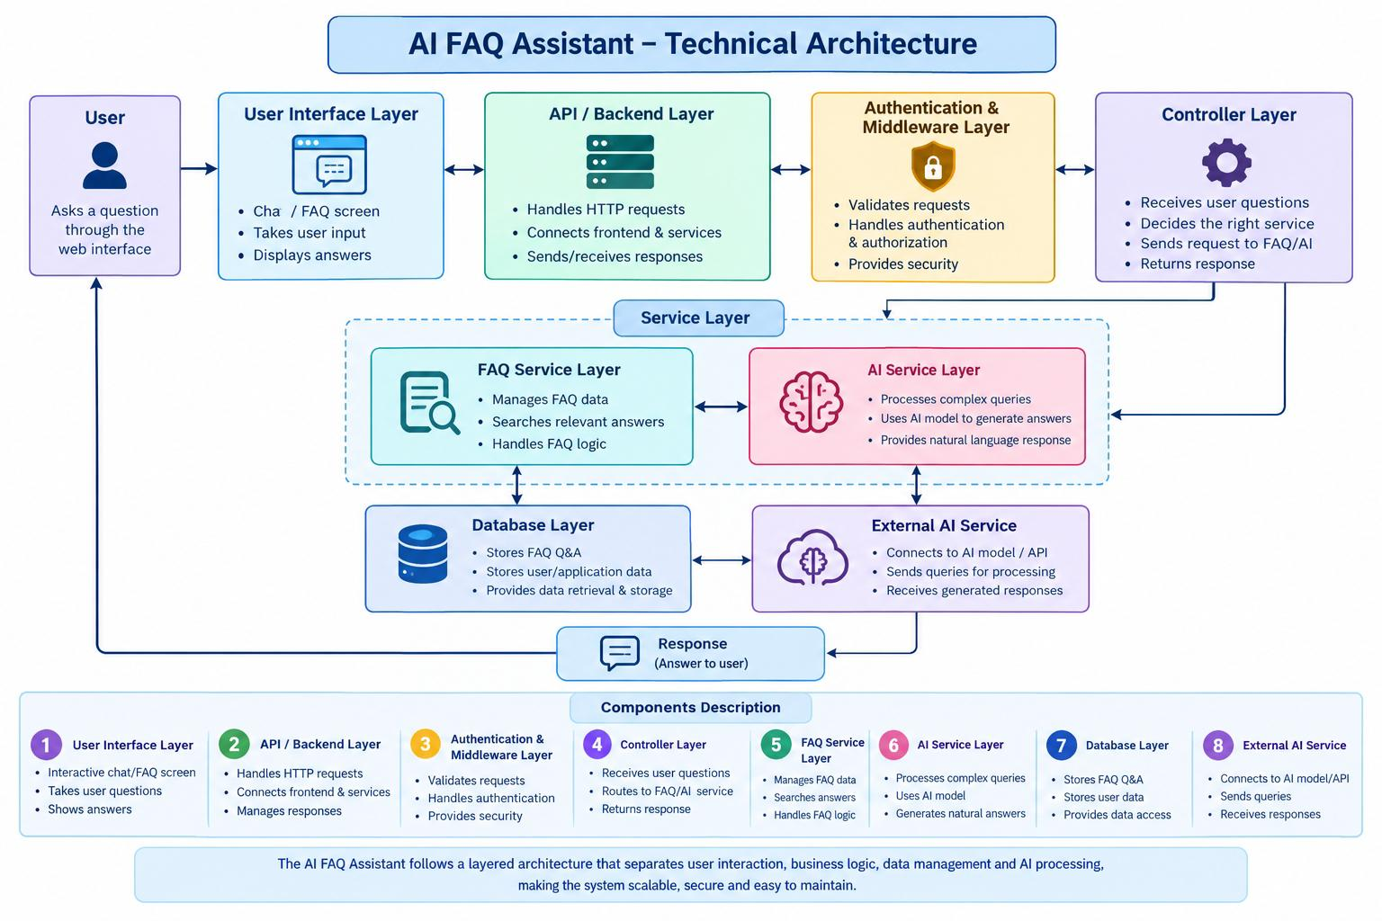

11.ER-Diagram
Description
The backend database of the AI FAQ Assistant consists of multiple MongoDB collections that store and manage user information, frequently asked questions, categories, and AI-generated responses. The collections are logically connected to support user authentication, FAQ management, category organization, and AI-based FAQ generation.
1. User Entity
- _id – Primary Key (ObjectId)
- name – String, Required
- email – String, Required, Unique
- password – String, Hashed, Required
- role – String, Default: "user"
- createdAt – Date
- updatedAt – Date
2. FAQ Entity
- _id – Primary Key (ObjectId)
- question – String, Required
- answer – String, Required
- category – String, Required
- createdBy – Reference to User
- createdAt – Date
- updatedAt – Date
3. AI Generation Entity (Logical)
This entity represents the FAQ content generated dynamically using Google Gemini AI before being stored in the FAQ collection.
- topic – String
- generatedQuestion – String
- generatedAnswer – String
- generatedCategory – String
- generatedAt – Date
4. Category Entity
The Category entity is used to organize FAQs into different topics for easier management and retrieval.
- _id – Primary Key (ObjectId)
- categoryName – String, Required
- description – String
- totalFAQs – Number
- createdAt – Date
Relationships
- User → FAQ: One user can create multiple FAQs.
- FAQ → Category: Each FAQ belongs to a category.
- AI Generation → FAQ: AI-generated questions and answers can be stored as FAQs.
- FAQ → Tag: An FAQ can have multiple tags if tagging is implemented.
Database Technology
MongoDB is used as the database because it stores FAQ data in a flexible document-oriented format and is suitable for handling dynamically generated AI content.

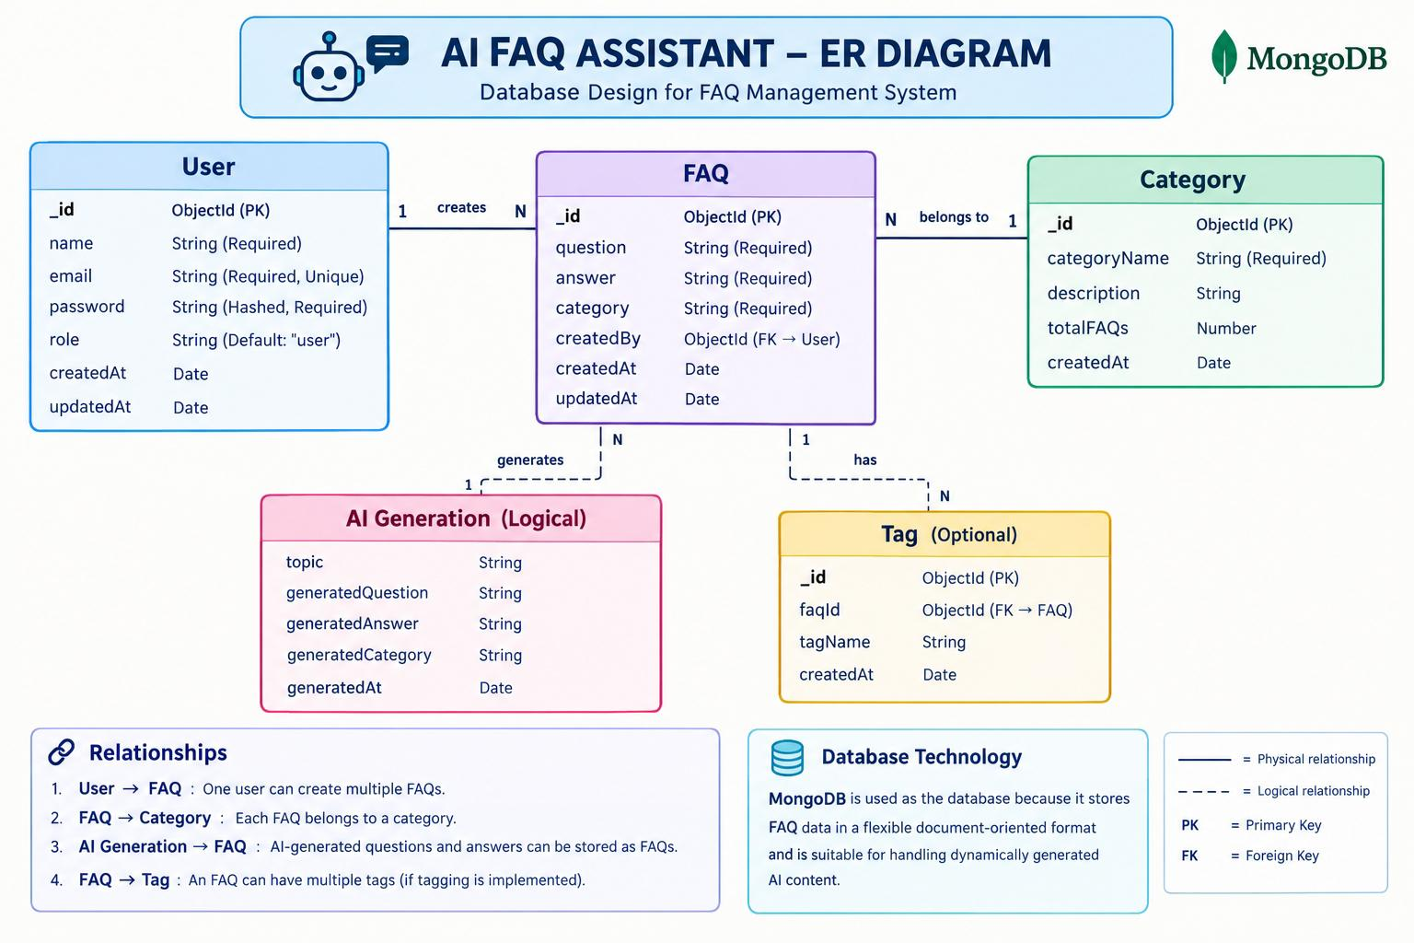

12.Features of AI FAQ Assistant
- AI-Powered FAQ Generation: Uses Google Gemini AI to generate relevant questions, answers, and topic suggestions.
- Smart FAQ Search: Allows users to quickly find relevant answers using keyword-based/semantic search.
- User Authentication: Provides secure JWT-based authentication and authorization for protected features.
- FAQ Management: Supports complete CRUD operations to create, view, update, and delete FAQ records.
- Category Management: Organizes FAQs into different categories for easy navigation and retrieval.
- Secure Password Storage: Protects user passwords using bcrypt hashing before storing them in the database.
- MongoDB Database: Stores FAQ records, categories, and user information using a flexible NoSQL database.
- Data Validation: Uses Mongoose schema validation to maintain data accuracy and consistency.
- RESTful API: Provides modular Express.js REST APIs for communication between the frontend and backend.
- Error Handling: Provides centralized error handling to give consistent responses and improve system reliability.

13.Roles and Responsibilities
1. Admin
- Manage registered users and their access.
- Manage all FAQ records in the system.
- Create, update, and delete FAQs when required.
- Monitor AI-generated FAQ content.
- Manage FAQ categories.
- Maintain overall system functionality.
2. Content Creator
- Create new FAQ records.
- Edit and update their own FAQs.
- Delete their own FAQ records.
- Generate FAQs using Google Gemini AI.
- Organize FAQs into appropriate categories.
3. Authenticated User
- View available FAQs after login.
- Search FAQs using keywords.
- Generate AI-assisted answers for queries.
- Access their profile information.
- Access features available to authorized users.
4.Public User
- View published FAQs without authentication.
- Search available FAQ content.
- Cannot create, edit, or delete FAQs.
- Cannot access protected API endpoints.

14.MVC Pattern
The AI FAQ Assistant follows a modular Model–View–Controller (MVC) architecture that separates data management, request processing, and API communication. This separation makes the system easier to maintain, test, and extend.
Model Layer – Data & AI Knowledge
The Model Layer manages the application’s data structure and database operations.
- Uses Mongoose schemas to define FAQ, user, and category data.
- Stores and retrieves information from MongoDB.
- Performs schema validation before storing data.
- Handles FAQ Create, Read, Update, and Delete (CRUD) operations.
- Maintains relationships between users, FAQs, and categories.
Controller Layer – Intelligence & Request Processing
The Controller Layer acts as the main processing unit of the AI FAQ Assistant.
- Receives requests from the API routes.
- Validates and processes user requests.
- Handles FAQ creation, searching, updating, and deletion.
- Communicates with the Google Gemini AI service for AI-generated FAQs and answers.
- Applies JWT authentication and authorization for protected operations.
- Sends appropriate success or error responses to the client.
View Layer – API Response Interface
Since the project is primarily a RESTful backend system, the View Layer is represented by the API response interface rather than traditional HTML pages.
- Receives requests through Express.js REST API routes.
- Routes requests to the appropriate controllers.
- Returns structured JSON responses.
- Provides FAQ search results, AI-generated answers, and operation status to the client.
- Ensures consistent communication between the backend and the user-facing application.
AI Service Layer – Intelligent Assistance
To make the MVC architecture unique to your project, you can include an additional AI Service Layer alongside MVC.
- Connects the application with Google Gemini AI.
- Generates relevant FAQ questions and answers.
- Provides AI-assisted responses to user queries.
- Supports topic suggestions and intelligent FAQ generation.
Overall Flow
User / Client
↓
REST API Routes
↓
Controller Layer
↙︎ ↘︎
Model Layer AI Service
↓ ↓
MongoDB Google Gemini AI
↘︎ ↙︎
Controller
↓
JSON Response
↓
User / Client

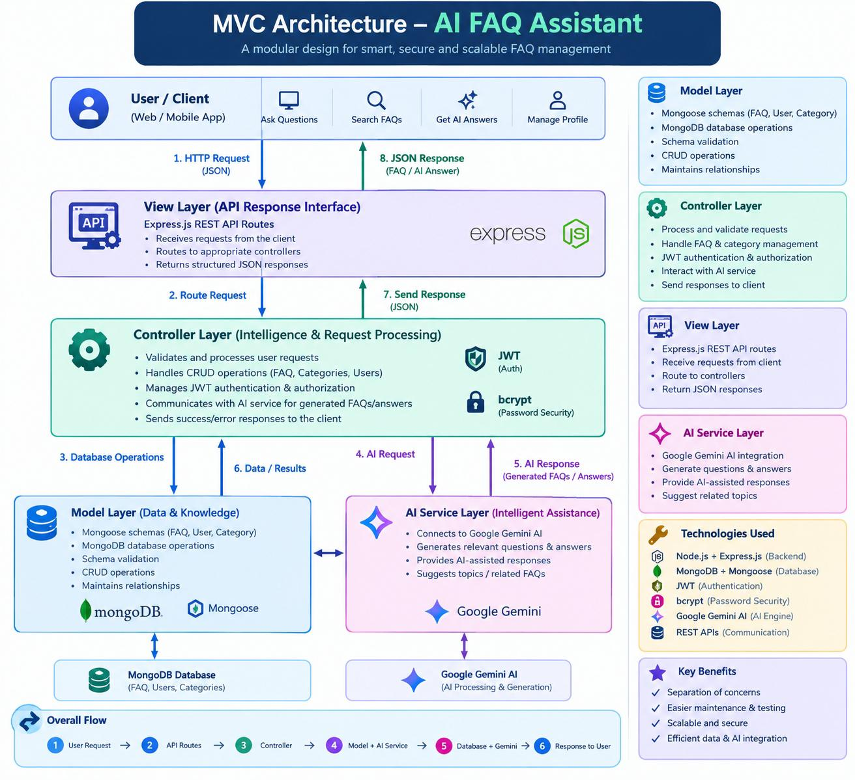
15.User Flow
Description
The AI FAQ Assistant provides a simple interaction flow between the user and the AI system. The user enters a question, and the system processes the query to identify the most relevant information from the FAQ/Knowledge Base. The AI then generates and displays a suitable answer. If no relevant information is found, the system informs the user and allows them to ask another question.
User Flow Diagram
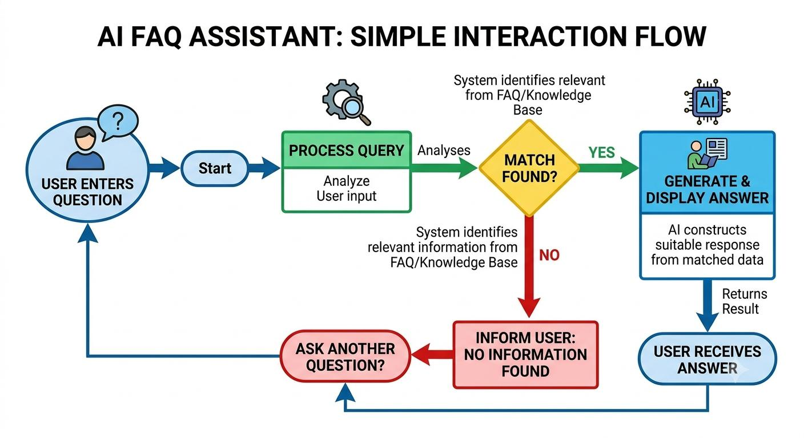
16.Project Folder Structure
The AI FAQ Assistant is organized using a modular backend folder structure. This structure separates database configuration, business logic, authentication, API routes, AI services, and utility functions, making the application easier to develop, maintain, and scale.
Folder Structure
AI FAQ Assistant
│
├── src
│ ├── config
│ │ └── db.js
│ ├── controllers
│ │ ├── aiController.js
│ │ ├── authController.js
│ │ └── faqController.js
│ ├── middleware
│ │ ├── authMiddleware.js
│ │ ├── errorMiddleware.js
│ │ └── validationMiddleware.js
│ ├── models
│ │ ├── FAQ.js
│ │ └── User.js
│ ├── routes
│ │ ├── aiRoutes.js
│ │ ├── authRoutes.js
│ │ └── faqRoutes.js
│ ├── services
│ │ └── geminiService.js
│ ├── utils
│ │ └── helpers.js
│ ├── app.js
│ └── server.js
│
├── .env
└── AI_FAQ_Assistant_API.postman_collection

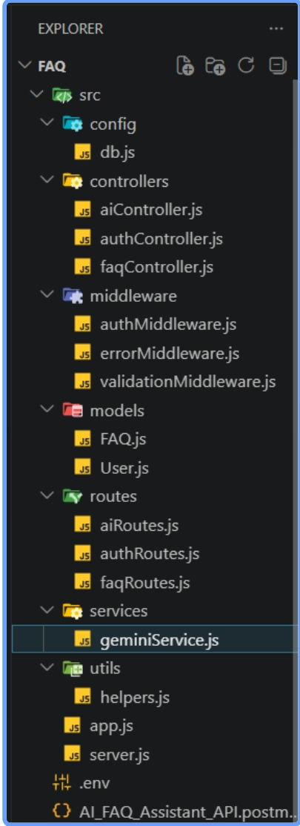
Description of Components
1.Config
Manages database connection ana configuration settings.
2.Controllers
Process user’s requests and implements application logic.
3.Middleware
Provides authentication validation and error handling.
4.Models
Define the structure of user and FAQ data stored in MongoDB.
5.Routes
Defines API endpoints for authentication, FAQs, and AI features.
6.Services
Connects the application with the Gemini AI service for intelligent responses.
7.Utils
Contains reusable helper functions used throughout the application.

17.Server Setup
1. Backend Environment Setup
The backend of the AI FAQ Assistant is developed using Node.js and Express.js. The server acts as the communication layer between the user interface, FAQ data, database, and AI service.
The project is initialized using:
npm init -y
The required backend dependencies are installed using:
npm install express mongoose dotenv cors jsonwebtoken bcrypt @google/genai
2. Server Configuration
The server is configured to:
- Handle API requests from the frontend.
- Connect the application with the MongoDB database.
- Process FAQ-related requests.
- Communicate with the AI service to generate intelligent answers.
- Manage user authentication and authorization.
- Enable secure communication between frontend and backend.
- Store sensitive configuration values using environment variables.
3. Environment Configuration
An .env file is used to store sensitive configuration details such as:
PORT=5000
MONGODB_URI=your_mongodb_connection_string
JWT_SECRET=your_secret_key
GOOGLE_API_KEY=your_ai_api_key
4. Backend File and Folder Structure
ai-faq-assistant-api/
│
├── .env
├── package.json
│
└── src/
├── app.js
├── server.js
│
├── config/
│ └── database.js
│
├── controllers/
│ ├── authController.js
│ └── faqController.js
│
├── models/
│ ├── User.js
│ └── FAQ.js
│
├── routes/
│ ├── authRoutes.js
│ └── faqRoutes.js
│
├── middleware/
│ └── authMiddleware.js
│
└── utils/
└── aiHelper.js
5. Server Initialization
The Express server initializes the application and provides API endpoints for the AI FAQ Assistant. Middleware such as CORS and JSON parsing is configured before registering the application routes.
The server listens on the configured port and remains ready to receive requests from the frontend.

18.Backend Development

Core System Script Implementations
- Gateway Server Node (src/server.js)
This main entrance mechanism aggregates environment variables, triggers database listeners, and binds network listeners to active environment ports:
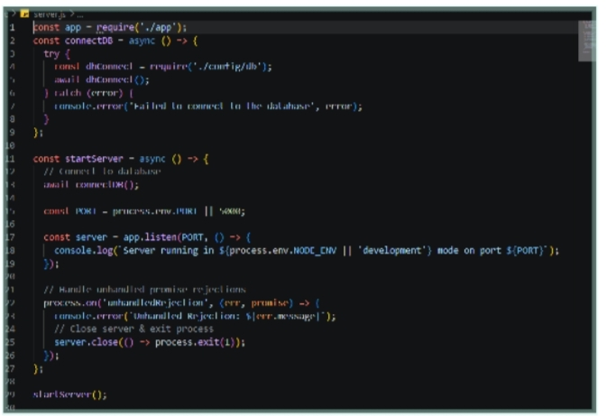

- Gateway Express Setup (src/app.js)
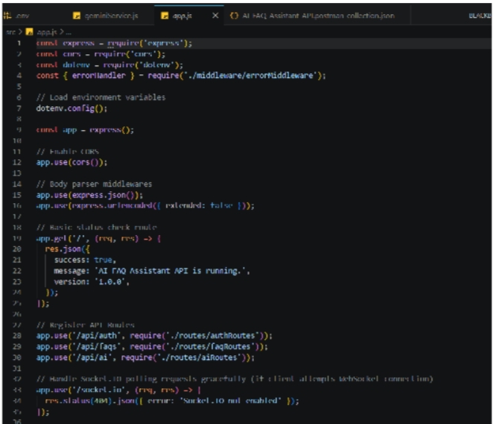

- Security Access Middleware (src/middleware/authMiddleware.js)

Intercepts incoming target queries, extracts transmission header authorization records, and validates token identity context claims:
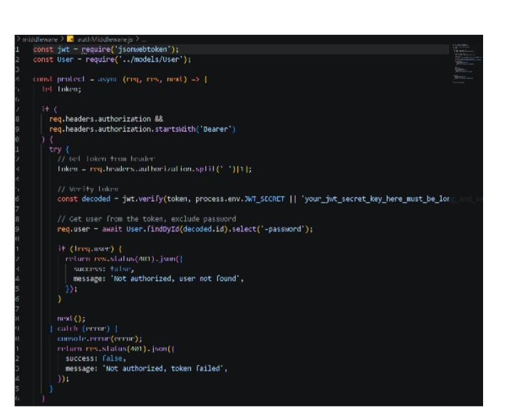

Centralized Error Handler Middleware (src/middleware/errorMiddleware.js)



19.CONFIGURE MONGODB
- MongoDB Configuration
MongoDB is used as the database for the AI FAQ Assistant to store and manage frequently asked questions, answers, categories, and user interactions. The Node.js backend connects to MongoDB using Mongoose, which provides an easy way to define schemas and interact with database collections.
2. Install Mongoose
In the Node.js project directory, install Mongoose using:
npm install mongoose
Mongoose acts as an interface between the Node.js backend and the MongoDB database.
3.Create Database Connection
The backend establishes a connection with MongoDB using a MongoDB connection string.
Const mongoose = require(“mongoose”);

Mongoose.connect(process.env.MONGODB_URI)
.then(() => {r
Console.log(“MongoDB connected successfully”);
})
.catch((error) => {
Console.error(“MongoDB connection error:”, error);
});
The database URL is stored securely in the .env file rather than directly inside the source code.
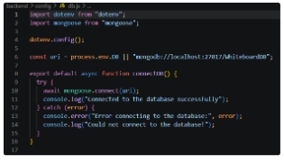

4. Create FAQ Schema
The FAQ schema defines how FAQ information is stored in MongoDB.
Const mongoose = require(“mongoose”);

Const faqSchema = new mongoose.Schema({
Question: {
Type: String,
Required: true
},
Answer: {
Type: String,
Required: true
},
Category: {
Type: String
}
});

Module.exports = mongoose.model(“FAQ”, faqSchema);

